***Network Design : Principles, Protocols and Applications***

***EECE.5830 – 201***

***Instructor:*** *Prof. Dr. Vinod Vokkarane*

*Programming Project Phase 1: UDP Client and Server*

*By,*

* *Naga Ganesh Kurrapati*
* *Ritesh Dumpala Basaveswara*

Table of contents

1. UDP Client
2. UDP Server
3. Execution of the program

I. UDP Client

**Class name**: UDPClient

**Purpose**: The purpose of this class is to send data (.bmp file) from the client to server which is read through a input file stream, send the file through a UDP datagram socket, to receive the response (.bmp file) from the server and to write it to an output file stream.

**Data types:**

ByteBuffer: Stores a copy of bytes of the file from the file channel.

Byte[]: It is an array of bytes of a file used to pass the data through the datagram channel.

II. UDP Server

**Class name**: UDPServer

**Purpose**: The purpose of this file is to receive data (.bmp file) from the client through an UDP data gram socket which is written to an output file stream, send the response (.bmp file) to the client which is read from output file stream.

**Data types:**

ByteBuffer: Stores a copy of bytes of the file from the file channel.

Byte[]: It is an array of bytes of a file used to pass the data through the datagram channel.

III. Execution of the program

1. Initial contents of the Client and Server folders

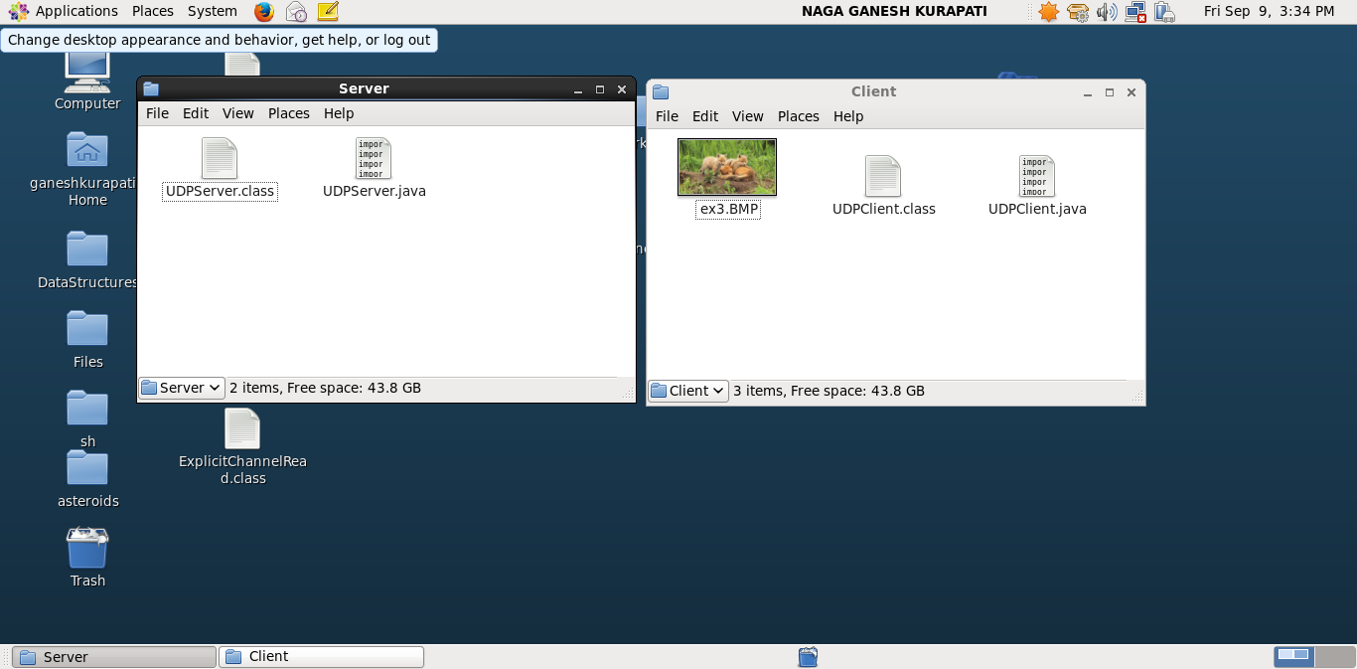

1. Setting up the server by executing the UDPServer program

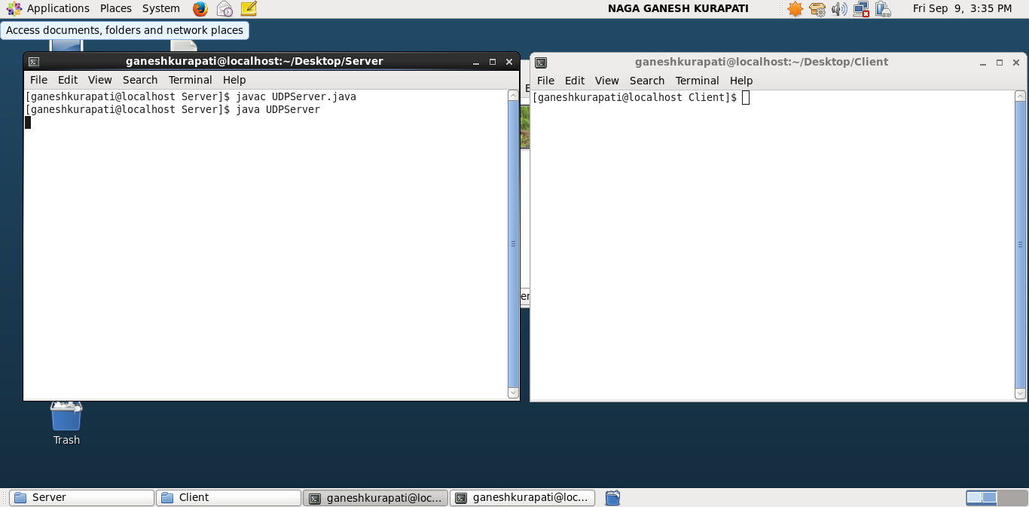

1. Setting up the client by executing the UDPClient program

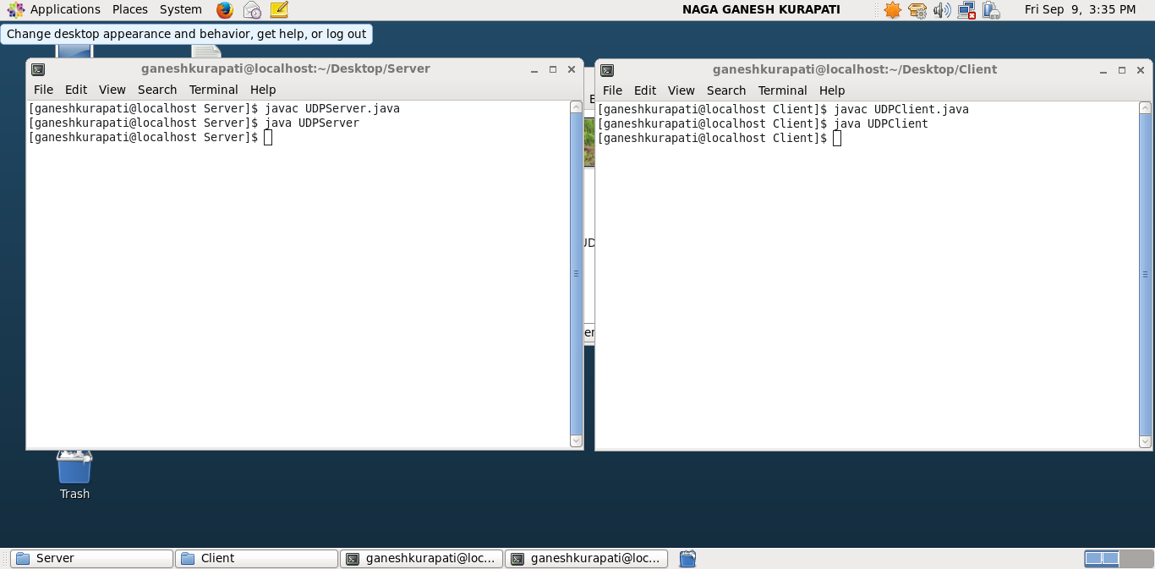

1. Final contents of the folder after sending and receiving the .bmp file

